**Exercise 3: Stored Procedures**

* **Scenario 1:** The bank needs to process monthly interest for all savings accounts.

**Question:** Write a stored procedure ***ProcessMonthlyInterest*** that calculates and updates the balance of all savings accounts by applying an interest rate of 1% to the current balance.

* The `ProcessMonthlyInterest` procedure updates the balance of savings accounts by applying a 1% interest rate, setting the `LastModified` date, and committing the changes. It utilizes a cursor to iterate through all savings accounts, adjusting each account's balance accordingly.
* If an error occurs during execution, the transaction is rolled back, and an error message is printed. After defining and running the procedure, a query is executed to verify that the data in the `Accounts` table reflects the updated balances for savings accounts.

**The OUTPUT :**

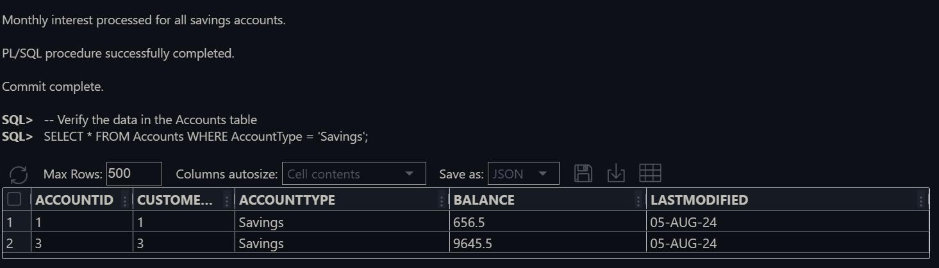

* **Scenario 2:** The bank wants to implement a bonus scheme for employees based on their performance.
* **Question:** Write a stored procedure **UpdateEmployeeBonus** that updates the salary of employees in a given department by adding a bonus percentage passed as a parameter.
  + The `UpdateEmployeeBonus` procedure adjusts employee salaries by adding a percentage-based bonus for a specified department and commits the changes. It also outputs the number of rows updated and handles errors by rolling back changes and displaying an error message if needed.
* A test block calls this procedure to apply a 10% bonus to the IT department, managing any exceptions that occur during the process. Following the procedure execution, a `SELECT` statement retrieves and displays the updated salaries for the IT department to verify that the changes were applied correctly.

**The OUTPUT** :

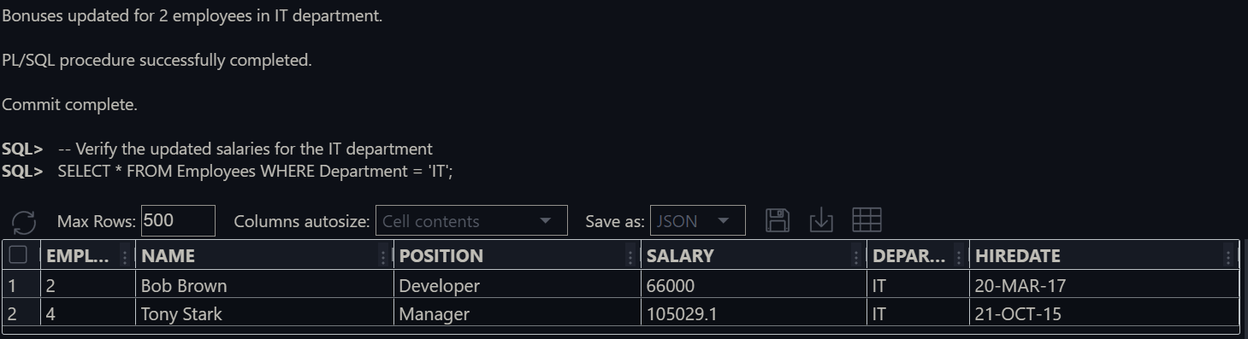

* **Scenario 3:** Customers should be able to transfer funds between their accounts.
* **Question:** Write a stored procedure ***TransferFunds*** that transfers a specified amount from one account to another, checking that the source account has sufficient balance before making the transfer.
* Defines a stored procedure TransferFunds to transfer an amount, checking for balance before updating and recording the transaction. It includes error handling. Insert sample account records and creates a sequence for unique transaction. Lastly, Test the Procedure with sufficient and insufficient balance.

The OUTPUT :

